 | EUROPEAN COMMISSION  DIRECTORATE-GENERAL  INFORMATICS  Information systems Directorate

European Commission
e-Trustex Use Case Specification: Submit Attached Document

Date: | 11/03/2015
Version: | 1.000
Authors: | Anamaria BATRINU
Revised by: | Technical Review:  Quality Review:
Approved by:
Public:
Reference Number:

TABLE OF CONTENTS
1. Use-Case Description 3
2. References 3
3. Points of Extensions 3
3.1. Points of extension mapping 3
3.2. Document Type Code 4
3.3. Party Roles 4
3.4. Document Identifier 4
3.5. Document Issue Date 4
3.6. Synchronous XSD Validation 4
3.7. Synchronous Schematron Validation 4
3.8. Synchronous Specific Validation 5
3.8.1. Synchronous SLA Validation 5
3.8.2. Other specific validation 5
3.9. Synchronous Business Specific Processing 5
3.10. Asynchronous XSD Validation 5
3.11. Asynchronous Business Rules Validation 5
3.11.1. Asynchronous Schematron Validation 5
3.11.2. Asynchronous Parent-Child Relationship Validation 6
3.11.3. Reprocessing Timeframe for Parent Document 6
3.11.4. Asynchronous Specific Validation 6
3.12. Asynchronous Business Specific Processing 7
3.12.1. Human Readable Generation 7
3.12.2. SLA Policy Validation 7
3.12.3. Other specific processing 7
3.13. Availability Notification 7
3.14. State Machine 7
3.14.1. Transition to state Processed 7
3.14.2. Transition to state Rejected 8
3.15. Dispatching 8
4. Additional Information 8
4.1. Specific Exceptions 8
4.1.1. System perform Asynchronous Specific Validation and RULE27 fails 8

Document History

Version | Date | Comment | Modified Pages
1.000 | 11/03/2015 | Creation | All

Use-Case Description
This Use Case describes the service that enables parties to send AttachedDocument document via electronic means using the e-TrustEx platform. It implements the Submit Document Template that extends the generic use case UC1_002 Process Asynchronous Message to AttachedDocument document. The attached document is sent as a binary multipart, so it is not is included in the business document (the AttachedDocument xml).

References
Document Title | Document Reference
Submit Document Template | Version 2.005 of https://webgate.ec.europa.eu/CITnet/svn/ETRUSTEX/trunk/001%20e-TrustEx/002%20Requirements/Use%20Case%20Model/New%20Use%20Cases/Submit%20Document%20Template%20Use%20Case%20Specification_2.0.doc
UC1_002 Process Asynchronous Message | https://webgate.ec.europa.eu/CITnet/svn/ETRUSTEX/trunk/001 e-TrustEx/002 Requirements/Use Case Model/New Use Cases/UC1_002 Process Asynchronous Message.doc
Use Case eTrustex – Submit Application Response | https://webgate.ec.europa.eu/CITnet/svn/ETRUSTEX/trunk/001 e-TrustEx/002 Requirements/Use Case Model/New Use Cases/UC1_003 Submit Application Response Use Case Specification_2.0.doc
AttachedDocument XSD document | https://webgate.ec.europa.eu/CITnet/svn/ETRUSTEX/trunk/001 e-TrustEx/003 Architecture/001 Data Model/200 XSD/xsd/maindoc/UBL-AttachedDocument-2.0.xsd
AttachedDocument Schematron rules document | To be defined.
Code List Document | https://webgate.ec.europa.eu/CITnet/svn/ETRUSTEX/trunk/001 e-TrustEx/003 Architecture/001 Data Model/000 Code Tables/EC_CodeList_e-TrustEx.xls
Human Readable Template | N/A

Points of Extensions

Points of extension mapping
Point of extension (in this document) | Extended point (in Asynchronous Use Case)
Document Type Code | Point of extension 2  Point of extension 4  Point of extension 9
Party Roles | Point of extension 1
Document Identifier | Point of extension 3
Document Issue Date | Point of extension 8
Synchronous XSD Validation | Point of extension 5
Synchronous Schematron Validation | Point of extension 6
Synchronous Specific Validation | Point of extension 7
Synchronous Business Specific Processing | Point of extension 17
Asynchronous XSD Validation | Point of extension 10
Asynchronous Schematron Validation | Point of extension 11
Asynchronous Parent-Child Relationship Validation | Point of extension 12
Reprocessing Timeframe | Point of extension 16
Asynchronous Specific Validation | Point of extension 18
Data Extraction | Point of extension 13
Asynchronous Business Specific Processing | Point of extension 14
Availability Notification | Point of extension 19
Dispatching | Point of extension 15

Document Type Code
The document type code for AttachedDocument is 916 and it is defined in Code List Document, under the sheet DocumentTypeCode.

Party Roles
The AttachedDocument document must be sent by a Party having Any Role and received by a Party having Any Role.

Document Identifier
The document identifier can be found via the following Xpath expression:
\\AttachedDocument\cbc:ID

Document Issue Date
The document issue date can be found via the following Xpath expression:
\\ AttachedDocument \cbc:IssueDate

Synchronous XSD Validation
N/A

Synchronous Schematron Validation
N/A

Synchronous Specific Validation

Synchronous SLA Validation
N/A

Other specific validation
N/A

Synchronous Business Specific Processing
System performs the following synchronous business processing:
- Binary is saved together with the following information in the system's database:
  - The type of the binary file
  - Mime type of binary file
  - The message id of the message is linked to
  - Binary size
  - Creation user being the issuer party username

Asynchronous XSD Validation
The document must be valid according to XSD documentAttachedDocument.

Asynchronous Business Rules Validation

Asynchronous Schematron Validation
The document must be valid according to the following set of rules implemented in the Schematron documentAttachedDocument:
ID | Description | Element path | Severity | Category | Subcategory
RULE1/ RRC40586 | The Address Format Code must have a valid value | */PostalAddress/AddressFormatCode | Soft | Message content check | Codelist validation
RULE6/ RRC40591 | The Country Identification Code must be a valid value | */PostalAddress/Country/IdentificationCode | Soft | Message content check | Codelist validation
RULE21/ RRC40592 | The Tax Type Code must be a valid value | */PartyTaxScheme/TaxScheme/TaxTypeCode | Soft | Message content check | Codelist validation
RULE37/ RRC17976 | The type code of the AttachedDocument parent document must be a recognized value. | AttachedDocument/ParentDocumentTypeCode | Hard | Message content check | Codelist validation
RULE45/ RRC40587 | The Street Name must not be empty | */PostalAddress/StreetName | Soft | Message content check | Codelist validation
RULE46/ RRC40588 | The City Name must not be empty | */PostalAddress/CityName | Soft | Message content check | Codelist validation
RULE47/ RRC40589 | The Postal Zone must not be empty | */PostalAddress/PostalZone | Soft | Message content check | Codelist validation
RULE48/ RRC40590 | The Country element must not be empty | */PostalAddress/Country | Soft | Message content check | Codelist validation
RULE83/ RRC40593 | The Tax Scheme Identifier must be a valid value | */PartyTaxScheme/TaxScheme/ID | Soft | Message content check | Codelist validation
RULE255/ RRC17972 | Element Attachment is mandatory, but is not allowed to have any content in this document | AttachedDocument/Attachment | Soft | Message content check | Codelist validation
RULE320/ RRC17973 | An AttachedDocument must not refer to an AttachedDocument in the ParentDocumentTypeCode element | AttachedDocument/ParentDocumentTypeCode | Hard | Message content check | Codelist validation

Asynchronous Parent-Child Relationship Validation
The parent document, if it exists, must be valid according to the following specific rules:
N/A

Reprocessing Timeframe for Parent Document
The reprocessing of the message is done during the following timeframe: 2 minutes

Asynchronous Specific Validation
The document must be valid according to the following specific rules:
ID | Description | Element path | Severity | Category | Subcategory
RULE27/ RRC17967 | Multipart Types are controlled via the MimeCode, which needs to have a valid value |  | Hard | Integration check | Codelist validation

Asynchronous Business Specific Processing

Human Readable Generation
N/A

SLA Policy Validation
N/A

Other specific processing
N/A

Availability Notification
The available notification can be found via the following Xpath expression:
N/A

State Machine
The following state machine shows the usual (generic) states that are Submitted, Received and Error. Beside these states some specific states are displayed in blue: Approved and Rejected.

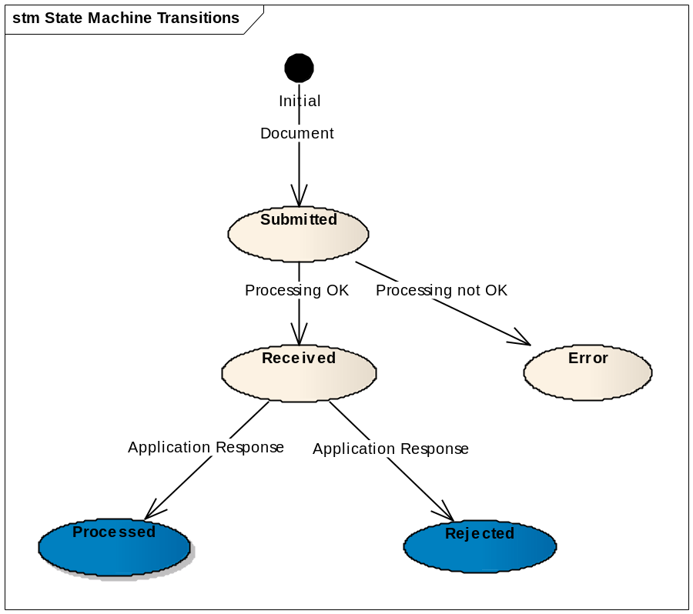

Transition to state Processed
At this point, the Use Case Submit Application Response is included.
When an application response referencing an existing AttachedDocument document in state received arrives in the system with a response code 916:1 the state of the AttachedDocument document becomes Processed.

Transition to state Rejected
At this point, the Use Case Submit Application Response is included.
When an application response referencing an existing AttachedDocument document in state received arrives in the system with a response code 916:2 the state of the AttachedDocument document becomes Rejected.

Dispatching
The following routing rules are used for dispatching the message:
There is no general rule for AttachedDocument, but there might be specific routing configurations depending on the business need (for certain parties, interchange agreements etc.).

Additional Information

Specific Exceptions
The exceptions described here below complete the list of business exceptions in the section 3.3.2 Asynchronous Exceptional Flow from UC1_002 Process Asynchronous Message and follow the same pattern.

System perform Asynchronous Specific Validation and RULE27 fails
- DCT:D = 916:4
- Error description = Hard business rule violated

